Experiment No. 10

Aim: To implement Group Communication.
Theory:
Group communication refers to the exchange of messages or information between multiple participants, or a group, as opposed to one-to-one communication. This form of communication is common in collaborative environments like work teams, chat groups, or broadcast systems where multiple parties need to receive the same information simultaneously. In computing and networking, it is used to ensure that messages sent by one entity are distributed to all members of a designated group.
Key Concepts of Group Communication:
- Multicast vs Broadcast:
  - Multicast sends messages to a specific group of devices (group members) rather than everyone on the network, optimizing resource usage.
  - Broadcast sends messages to all devices on a network, which is less efficient as not all devices may need the message.
- Protocols for Group Communication:
  - IP Multicast: A protocol where messages are sent to multiple recipients using the multicast IP address, saving bandwidth compared to unicast (one-to-one communication).
  - Reliable Group Communication: Ensures that all members of the group receive the message reliably, often involving acknowledgment and retransmission mechanisms.
  - Consensus Algorithms (e.g., Paxos, Raft): In distributed systems, these algorithms are used to achieve agreement on a single data value among a group of nodes, ensuring consistent communication and decisions.
- Roles in Group Communication:
  - Sender: The entity responsible for generating and sending the message.
  - Receiver(s): The group members that receive the message.
  - Coordinator: Sometimes a leader or centralized entity coordinates or facilitates communication within the group.
- Challenges in Group Communication:
  - Scalability: As the number of participants increases, maintaining communication efficiency can become difficult.
  - Latency: Delays in message delivery can affect the performance of group communication.
  - Consistency: In distributed systems, ensuring that all members have the same information at the same time is crucial.
  - Fault Tolerance: The system needs to handle failures of some participants without disrupting the overall communication.
Applications of Group Communication:
- Collaborative Software: Tools like Google Docs and Slack use group communication to synchronize data in real time among multiple users.
- Video Conferencing: Platforms such as Zoom or Teams enable multiple users to communicate simultaneously.
- Distributed Systems: Systems like Apache Kafka use group communication to ensure message delivery across a cluster of machines.
Conclusion: Group communication enables efficient information exchange among multiple participants, optimizing bandwidth and ensuring reliable message delivery. It is essential in collaborative and distributed systems, though challenges like scalability and fault tolerance must be addressed for effective communication.

Name: Prachi Gujar
Roll No.: 01 Batch: B1
Experiment No.: 10

//Server Program
import socket
import threading
# Function to handle clients
def handle_client (client_socket, clients):
while True:
try:
message = client_socket.recv(1024).decode('utf-8')
if not message:
break
print (f"Received: {message}")
broadcast (message, client_socket, clients)
except:
break
client_socket.close()
clients.remove(client_socket)
# Function to broadcast messages to all clients
def broadcast (message, client_socket, clients):
for client in clients:
if client != client_socket:
try:
client.send(message.encode('utf-8'))
except:
client.close()
clients.remove(client)
def main():
server = socket.socket (socket.AF_INET, socket.SOCK_STREAM)
server.bind(('0.0.0.0', 12345))
server.listen(5)
print("Server started. waiting for clients...")
clients = []
while True:
client_socket, addr = server.accept()
print(f"Client {addr} connected.")
clients.append (client_socket)
threading.Thread(target=handle_client, args=(client_socket, clients)).start()
if __name__ == "__main__":
main()
Output:
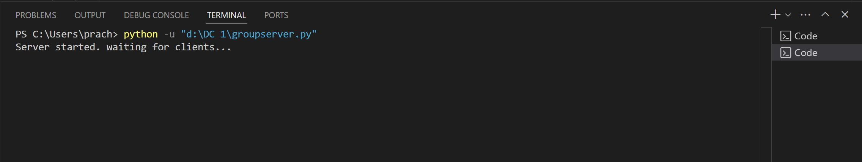
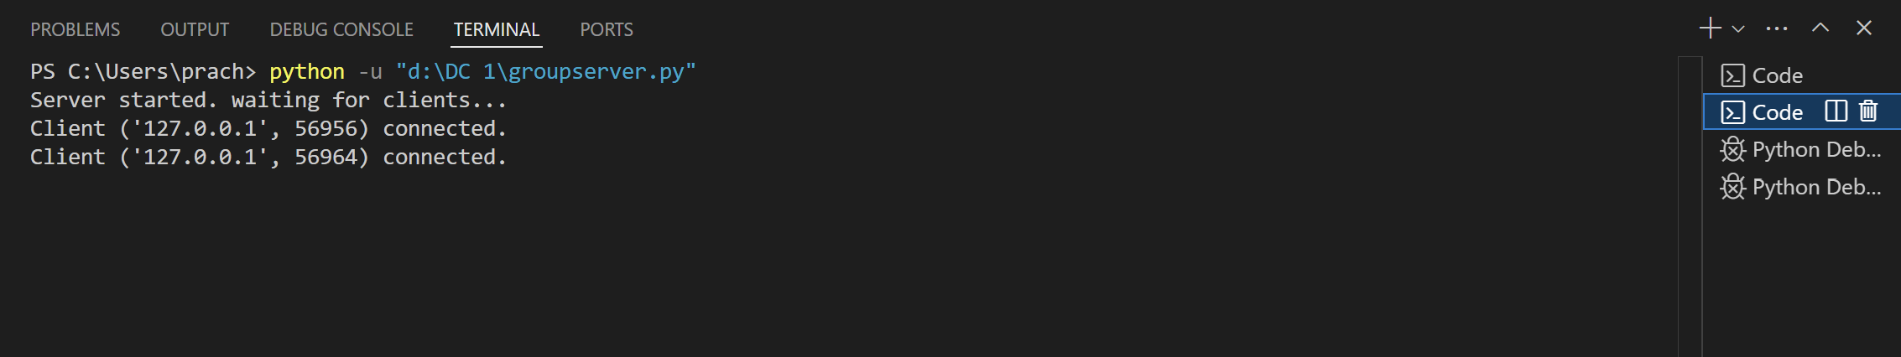

// Client1 Program
import socket
import threading
def receive_messages (client_socket):
while True:
try:
message = client_socket.recv(1024).decode('utf-8')
if not message:
break
print(f"\n{message}")
except:
print("Error in receiving message.")
break
def main():
client_socket = socket.socket (socket.AF_INET, socket.SOCK_STREAM)
client_socket.connect (('127.0.0.1', 12345))
threading. Thread(target=receive_messages, args=(client_socket,)).start()
while True:
message = input()
if message. lowen( ) == "exit":
break
client_socket.send(message.encode('utf-8'))
client_socket.close()
if __name__ == "__main__":
main()
Output:
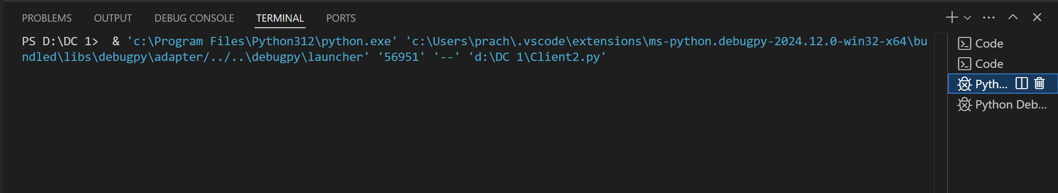
//Client2 Program
import socket
import threading
def receive_messages(client_socket):
while True:
try:
message = client_socket.recv(1024).decode('utf-8')
if not message:
break
print(f"\n{message}")
except:
print ("Error in receiving message.")
break
def main():
client_socket = socket.socket(socket.AF_INET, socket.SOCK_STREAM)
client_socket.connect(('127.0.0.1', 12345))
threading. Thread(target=receive_messages, args=(client_socket,)).start()
while True:
message = input()
if message.lower() == 'exit':
break
client_socket.send (message.encode('utf-8'))
client_socket.close()
if __name__ == "__main__":
main()

Output:
